
Evaluability assessment of cities implementing transparent, innovative, and effective solutions (cities)

December, 2016
This publication was produced at the request of the United States Agency for International Development. It was prepared by Dan Killian of Management Systems International, a Tetra Tech company.

August 2015
This publication was produced at the request of the United States Agency for International Development. It was prepared independently by consultants Pamela Putney, Nedjma Koval-Saifi, Huda Murad and Wisam Qarqash on behalf of Management Systems International, with the support of Integrated Solutions.

August 2015
This publication was produced at the request of the United States Agency for International Development. It was prepared independently by consultants Pamela Putney, Nedjma Koval-Saifi, Huda Murad and Wisam Qarqash on behalf of Management Systems International, with the support of Integrated Solutions.

August 2015
This publication was produced at the request of the United States Agency for International Development. It was prepared independently by consultants Pamela Putney, Nedjma Koval-Saifi, Huda Murad and Wisam Qarqash on behalf of Management Systems International, with the support of Integrated Solutions.

Evaluability assessment of cities implementing transparent, innovative, and effective solutions (cities)

December 2016
USAID/Jordan Monitoring and Evaluation Support Project (MESP)
Contracted Under AID-278-C-13-00009



Management Systems International
Corporate Offices
200 12th Street, South
Arlington, VA 22202 USA

DISCLAIMER
The authors’ views expressed in this publication do not necessarily reflect the views of the United States Agency for International Development or the United States Government.

CONTENTS

Acronyms 4
Executive Summary 5
Assesment Purpose 7
Background 7
CITIES 7
USAID Evaluation Practice 7
Evaluability Assessment 8
Findings 8
Plausibility 9
Utility 11
Feasibility 12
Design and Validity Threats 14
Conclusion 15
Annexes 16

Acronyms
[Examples below] | [update based on acronyms used in the report]
ADS | Automated Directives System
DEC | Development Experience Clearinghouse
FY | Fiscal Year
SOW | Statement of Work
USAID | U.S. Agency for International Development

Executive Summary
This rapid assessment reviews the prospects for rigorous evaluation of USAID/Jordan’s Cities Implementing Transparent and Innovative and Effective Solutions (CITIES) project. Available resources on evaluability suggest attention to the questions of plausibility, utility, and feasibility. Guidance from USAID/Jordan and the mission’s Monitoring and Evaluation Support Project (MESP) added the questions of external validity of results and options for tracking outcomes if impact evaluation was not feasible.
Plausibility
- Given the well-defined development hypothesis and logic model, and USAID’s long history in launching local governance initiatives, it is plausible to expect improvements in municipal responsiveness, effectiveness, and overall stability as a result of the intervention.

- Any evaluation activity should extend the CITIES logic model to include more detailed hypotheses of how project activities interact to produce a desired result. Such investigations should be a part of a project’s learning agenda and undergo continual evolution in response to lessons learned from implementation.

- For an evaluation to have any hope of measuring outcomes, CITIES must explicitly identify the full set of boundary partners (or zone of influence) for each activity, and adjust expectations of what can be achieved with each partner based on the extent to which they are exposed to project activities.

- Following from the previous point, the identification of boundary partners for a given activity should guide the evaluation estimation and data collection strategies. For example, there could be small-scale surveys targeting direct beneficiaries of a given infrastructure project.

- All key terms in a development hypothesis should be formally defined, and all outcomes mentioned in the development hypothesis should be measured.

Utility
- There appears to be sufficient demand for an evaluation from the key stakeholders of the USAID D&G and Program offices.

- Such interest in and demand for an evaluation should be formalized in the form of a set of evaluation questions / hypotheses and a supporting learning agenda. The learning agenda should be considered a living document that continually generates both questions and answers as project implementation unfolds.

- The case for proceeding with an evaluation of CITIES would be strengthened if USAID could identify additional uses for municipal-level survey data. Omnibus-type surveys with the potential to measure outcomes for more than one USAID or other donor projects should be considered. Such surveys could also be used to track risk factors, and/or serve as a surveillance system for events of interest.

Feasibility
- The feasibility of detecting CITIES outcomes depends on properly calibrating data collection and beneficiary selection based on identification and analysis of the zone of influence of CITIES activities. The extent to which CITIES might reach entire municipal populations remains unclear, but it is most likely that CITIES will need to target its data collection to those who benefit from service delivery initiatives, witness service delivery initiatives, or are exposed to a municipality’s community engagement.

- Credible estimation strategies depend on a) gathering data on most or all of Jordan’s municipalities, so that proper comparison units may be identified; and b) committing the resources to collect data on a large enough scale to enable robust inference.

- Several evaluation design choices are available so long as the conditions of the previous bullet point are met. Any design will have to address several validity threats to gain credibility.

Validity
- Quasi-experimental evaluation designs will generally provide internally valid estimates, so long as various threats to validity are identified and mitigated, and whose potential biasing effect is explicitly discussed.

- External validity of evaluation findings represent the highest evidentiary standard of impact evaluation, and should not be expected to be met based on the evaluation design. Proceeding with an evaluation should be motivated by a desire to validate project inputs and contribute to a learning agenda. From there, questions of external validity can be considered as a reflective exercise based on evaluation findings as well as qualitative judgement and triangulation with other data sources.

Next Steps
If USAID elects to proceed with an evaluation of CITIES, this assessment recommends the following next steps:
- CITIES should make explicit the application of its selection criteria to candidate municipalities. More generally, this refers to the imperative that in the event of non-random selection of treated units, the implementing party should make explicit whatever processes or considerations were applied to help select a unit for treatment. Knowledge of the selection process is crucial for the evaluator to properly understand what non-random selection processes are at work, design an appropriate estimation strategy, and sufficiently mitigate the validity threats such non-random processes pose to robust inference.

- USAID should formally establish what role, if any, MESP could play in supporting an evaluation. For example, MESP could use its staff of activity monitors to support small-scale surveys. MESP could also support the evaluation effort with input into development of the survey instrument and survey sampling plan.

Assesment Purpose
The Program office of the USAID mission in Jordan has requested that the Monitoring and Evaluation Support Project (MESP) conduct a desk study of relevant documents of the Cities Implementing Transparent, Innovative, and Effective Solutions (CITIES) activity, in order to ascertain the feasibility of implementing rigorous evaluation methods to estimate the activity’s impact on improving municipal governance. This evaluability assessment should present and explain estimation strategies that may fit the particular context of CITIES, highlight key implementation considerations as they relate to such estimation strategies, identify the key assumptions and conditions required for conducting an impact evaluation, and explore issues of the internal and external validity of impact estimates – with emphasis upon the extent to which the findings from the evaluation would be useful and relevant for application outside of the immediate implementation context.

Background

CITIES
The CITIES initiative is intended to support the Kingdom of Jordan’s recently-passed Decentralization and Municipalities laws, which operationalize King Abdullah’s vision of stronger grassroots participation to inform local level planning and decision making. In Jordan, that local level of governance is the municipality, which collectively cover an estimated 83 percent of Jordan’s population.

CITIES’ primary activities are to a) strengthen service delivery through construction and maintenance of public infrastructure, streets, markets, health, public safety, urban planning, permitting and licensing, management of solid waste and storm water, utilities, culture, and sport and recreation; b) improve local government operations, particularly in the fields of legal and regulatory framework, organizational structure, human resource management, financial management and budgeting, investment, public private partnerships, and inter-governmental coordination; and c) support municipalities in promoting community cohesion and resilience by ensuring inclusion of marginalized or minority groups in the citizen participation process.

By strengthening municipal institutional capacity, improving public service delivery, and strengthening community resilience and cohesion, it is expected that citizens will ultimately judge their local municipality to be more responsive to their needs and more effective in executing their core functions. These two results contribute to USAID’s development objective of stronger democratic accountability and a more stable, prosperous Jordan.

USAID Evaluation Practice
According to 2011 USAID policy, any project funded above the mean project value in an operating unit’s portfolio should undergo evaluation (performance or otherwise). Additionally, any project with an untested or new development hypothesis that was expected to be taken to scale should undergo an impact evaluation to rigorously validate the approach. The 2016 update to the evaluation policy revised these requirements, such that each operating unit managing program funds was required to conduct at least one evaluation per project. Evaluations could address a single activity or intervention, a set of activities or interventions within the project, questions related to the project, or cross-cutting issues within the project. The requirement to rigorously evaluate new and/or untested approaches remained in place. An added requirement was that each Country Development Cooperation Strategy (CDCS) period of performance include a “whole-of-project” performance evaluation, which was intended to encourage missions to apply evaluation questions to the strategy and/or sectoral level of analysis, rather than the activity level.

These requirements applied to CITIES suggest that specific activities that may be considered more evaluable than others could be usefully evaluated to provide useful and actionable information to USAID managers and leaders, while satisfying the requirements of the evaluation policy. CITIES would likely not be considered a new or untested approach that would require rigorous evaluation, given that USAID has launched municipal capacity building and citizen participation initiatives for several decades. Interestingly however, such initiatives do not seem to have built up a large body of evidence documenting efficacy or lessons learned. A review of recent work in this area is included below.

Evaluability Assessment
Perhaps surprisingly given USAID’s recent update of its Automated Directive System (ADS) and the Evaluation Policy, there is little guidance to USAID line managers about conducting an evaluability assessment, although there may be ad hoc guidance in the form of mission orders or individual consultancies. The most recent USAID resource is Dunn (2008), which offers easily digestible guidance motivated by principles of cost-effective impact assessment. A more in-depth resource is Davies (2013) where, in the context of Department for International Development (DfID) projects, he offers a comprehensive literature review around evaluability assessments, delivers 18 findings/recommendations to help donors plan for evaluations, and provides a detailed checklist as a resource for assessors. Peersman et al (2015) build on Dunn and Davies to consider evaluability specifically in relation to impact evaluation based on recent experience in Afghanistan, Nepal, and the Pacific, and offer a condensed checklist for assessors.

What these resources have in common is attention to the categories of plausibility (adequacy of intervention design), utility (evaluation would be useful and used), and feasibility (it is possible to measure what the project’s development hypotheses suggest you should find). This rapid assessment will similarly organize its findings according to plausibility, utility, and feasibility, as well as address validity issues. Where applicable, the assessment will also draw from recent evaluation work in democracy and governance projects.

Findings
This rapid assessment consisted of five days of desk review of relevant resources and CITIES documents. CITIES documentation included a draft workplan, draft M&E plan, and meeting notes between USAID, MESP, and CITIES staff. More general resources included evaluability documents, impact evaluations related to democracy and governance projects in general and local governance / citizen participation projects in particular, and more academic research on democracy and governance questions of interest.

Plausibility
Plausibility is primarily focused on the adequacy of the intervention design. Peersman’s checklist for plausibility includes the investment decision (problem statement, rationale, alignment/overlap with other donors), beneficiaries (properly defined, properly targeted, and those who may be excluded or experience negative results), and theory of change (clear causal chain tested with valid assessments, interactions of program components). This is consistent with Davies’ checklist, who also adds questions of validity/reliability and the testability of various linkages along the causal chain.

Estimation of impact is certainly plausible under CITIES’ draft theory of change and logic model. Under the CITIES development hypothesis, if municipal government effectiveness, service delivery, citizen engagement and inclusion of minority or marginalized groups is increased, this will lead to more trust and confidence in elected officials, enhanced democratic governance, and more stability. This is expressed in the following (simplified) logic model, with arrows denoting the “How” rather than “So what” line of questioning.
Figure 1 Simplified logic model, CITIES
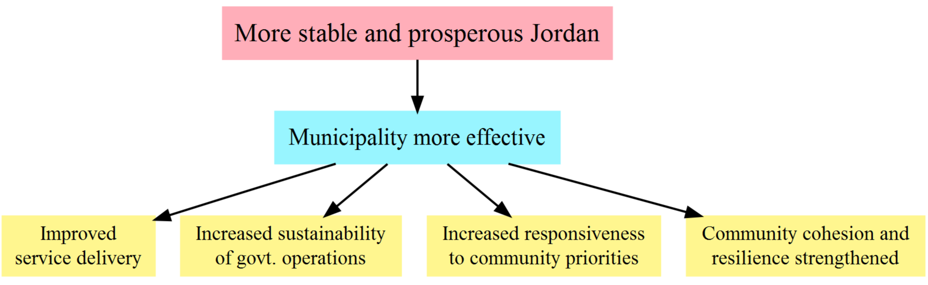

Consistent with ADS 201, the CITIES results framework is not necessarily a complete representation of the full strategy, but more of a snapshot for planning, implementation, and communication. The explanatory graphic in ADS 201 includes one example of multiple lines of causation (IR 2.2 feeds into both DO 2 and DO 3), but it is generally understood that a) the complexity of implementation makes it impossible to comprehensively capture the multiple and often non-linear pathways by which results are achieved, and b) even a high-level outline of the most likely causal pathways risks becoming overly complex and losing its utility as a tool for general planning and communication.

For these reasons, it can be helpful during an evaluation exercise to explore the causal pathways of a development hypothesis in more depth, and with more attention to how results would actually be measured. Consider the following model not based on the set of activities relating to a result, but based on how the activities may interact on the ground to cause a beneficiary to perceive her municipality as more responsive or more effective.
Figure 2 Causal loop diagram for municipal responsiveness and effectiveness
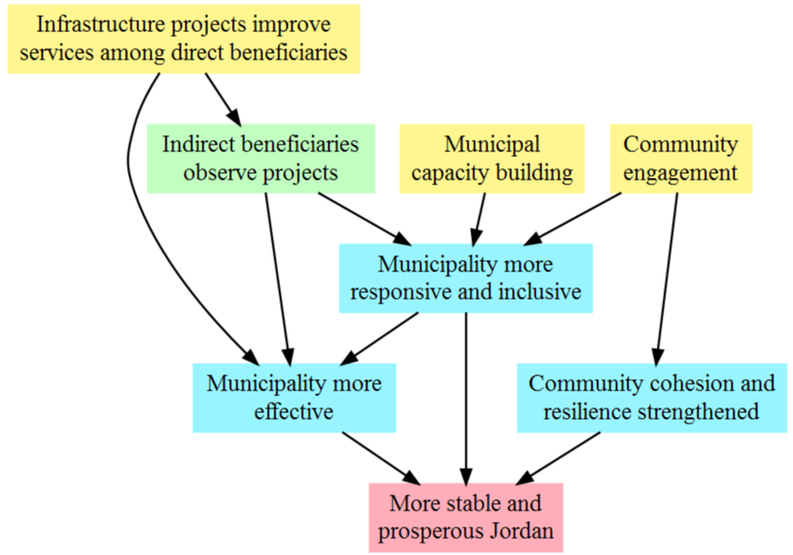

This model posits that responsiveness is one supporting factor of effectiveness, but not necessarily the only pathway. The model also begins to identify boundary partners, in that there could be different pathways to a result – as well as different magnitudes – based on whether a beneficiary directly benefitted from improved services or was aware that such initiatives were taking place even if he did not benefit directly. This has strong implications for evaluability, in that any evaluated activity or project must explicitly identify the entire universe of affected stakeholders and assess the extent to which each group may be affected. In the context of CITIES, a citizen of a municipality who neither benefits directly from service delivery initiatives nor is aware of such initiatives is unlikely to shift their perception of municipal governance. Conversely, one may hypothesize heterogeneous effects based on whether a beneficiary was exposed to a municipality’s community engagement, service delivery improvements, or both. A key consideration for both points is that such questions may be at least partially testable through empirical investigation, and can richly support the insight gained from a project’s learning agenda.

A final comment regarding the CITIES development hypothesis and logic model is that all key terms should be defined and measured. Implicit definitions in this assessment would be that responsiveness is a reflection of perceived effort by the municipal authorities to solicit and respond to citizen priorities, while effectiveness includes the extent to which the municipality can improve citizens’ quality of life through public services. Stability would be an aggregate measure of responsiveness, effectiveness, cohesion, and resilience.

In terms of measurements, the development hypothesis mentions democratic governance, trust and confidence in government officials, and overall stability as outcomes. However, only responsiveness and effectiveness are mentioned in the MEL plan. While democratic governance seems too vague to be a measureable and useful construct, the construct of stability could be seen as a DO or Goal level measure, and should be included in the MEL plan but recognized as a contextual indicator or a performance indicator with low attributional power. Trust and confidence in local officials are excellent measures and should be included in the MEL plan as contextual or performance indicators, or measured as part of the project’s learning agenda.

Overall findings with regard to the plausibility of impact are as follows:

- Given the well-defined development hypothesis and logic model, and USAID’s long history in launching local governance initiatives, it is plausible to expect improvements in municipal responsiveness, effectiveness, and overall stability as a result of the intervention.

- Any evaluation activity should extend the CITIES logic model to include more detailed hypotheses of how project activities interact to produce a desired result. Such investigations should be a part of a project’s learning agenda and undergo continual evolution in response to lessons learned from implementation.

- For an evaluation to have any hope of measuring outcomes, CITIES must explicitly identify the full set of boundary partners (or zone of influence) for each activity, and adjust expectations of what can be achieved with each partner based on the extent to which they are exposed to project activities.

- Following from the previous point, the identification of boundary partners for a given activity should guide the evaluation estimation and data collection strategies. For example, there could be small-scale surveys targeting direct beneficiaries of a given infrastructure project.

- All key terms in a development hypothesis should be formally defined, and all outcomes mentioned in the development hypothesis should be measured.

Utility
Utility is the assurance that there is sufficient demand for the evaluation from key stakeholders, that the type of evaluation (performance, impact, participatory, etc) match the expectations of key stakeholders, that there is explicit and actionable use for evaluation findings, and that there are well-posed questions of interest that stakeholders are interested in. Davies’ checklist adds the questions of handling the ethical dimension of evaluation and managing the risk of null or negative findings.

There appears to be sufficient interest within USAID to proceed with an impact evaluation if it is considered feasible, or to proceed with the most feasibly rigorous design even if would not meet the evidentiary standards of impact evaluation. CITIES would likely not be considered an untested hypothesis requiring validation, but there are still questions of development efficacy an evaluation would help answer. The foremost of these is the question of the relative merits of “hard” infrastructure projects or “soft” projects supporting citizen-government engagement and community cohesion and resilience. In the three related evaluation studies considered in this assessment, Afghanistan NSP and GoBifo Sierra Leone measured improved services but did not detect any change in “soft” measures such as citizen participation or engagement, cohesion, resilience, or social capital. Afghanistan MISTI, on the other hand, found stronger impacts among “soft” projects than “hard” projects, and also noticed a co-evolutionary relationship between perceptions of local government effectiveness and community cohesion and social capital. A CITIES evaluation could help address this open question of the relationship and relative merits of different types of programming at the local level. Another potential evaluation question would be whether municipal capacity building and service delivery improvements successfully mitigate the effect of recent refugee flows from Syria.

While there appears to be sufficient demand for an evaluation and useful questions such an evaluation could address, USAID should formalize its interest in evaluation by generating a set of questions for the evaluation to address.

Feasibility
Feasibility addresses the questions of documentation, related literature, existing data sources, capacity to execute among both the implementing and evaluating entities, and the adequacy of the evaluation design (as opposed to the intervention design).

This last question is the most crucial, for an ill-designed evaluation (or a decision to evaluate in an ill-fitting environment) might produce null findings that cast doubt on the efficacy of an otherwise sound intervention design and implementation. In the case of CITIES, the target beneficiaries are municipalities, and by extension the citizens living within such municipalities. However, it is entirely unclear (both from a theoretical standpoint and due to lack of information about the specifics of CITIES’ planned implementation) that successful implementation would result in changes in general perception at the population level unless there were very intensive, broad-based, and successful service delivery activities. As a result, CITIES and any evaluation team must conduct careful analysis of the zone of influence of CITIES as a whole but, perhaps more importantly, the zone of influence of specific activities or project components. Subsequently, these zones of influence should guide choices of where and when to collect data.

In terms of adequacy of evaluation design, any discussion of impact evaluation must include how to identify and measure a defensible counterfactual scenario of what would have happened to the treated units, if the project had never happened. The draft MEL plan mentions that random assignment of municipality to treatment is not feasible due to adherence of pre-determined criteria. The application of criteria does not automatically preclude randomization of treatment, and can actually support the process by establishing the stratifications of interest. However, given the large number of criteria to apply, it would certainly be impractical to do so.

As the MEL plan further establishes, in the absence of randomization of treatment, there are various quasi-experimental approaches that may be considered such as difference-in-differences or propensity score matching. Propensity score matching may be especially attractive in this situation, in that the municipality selection criteria immediately provides the discriminating factors of interest which can either be matched on directly, or used to generate a score that is then matched on. Such approaches would have to grapple with various validity threats, as discussed below.

In addition to these common methods to generate “as-if” random assignment, USAID and CITIES may also consider additional approaches:

- Randomized rollout. If there is sufficient lag between enrolling tranches of treated units, one may use a later-treated unit as the counterfactual for an earlier-treated unit. There generally should be at least a one year lag. This design precludes taking longer-term measures, as the comparison units are eventually treated, and one must also consider temporal effects for treatments that are staggered across time.

- Regression discontinuity. If a scoring system was assigned to the municipality selection criteria and a cutoff score established to assign municipalities to treatment, then one could use the discontinuity of the cutoff score as an exogenous break, and compare municipalities immediately above and below the cutoff score. This design can also use geography as a discontinuity, which would be more applicable to evaluation of specific infrastructure projects within a municipality rather than across municipalities.

- Synthetic controls. Where there are not enough municipalities to establish a balanced sample of treatment and control, one can customize a comparison group for each treated municipality by extracting specific features of comparison municipalities that are statistically similar to the treated units, thus generating a single blended unit composed of different aspects of the entirety of comparison municipalities. This approach can make the comparison group measures harder to relate to a real-world setting, but can solve the problem of an insufficient number of comparison units to draw from.

All of these designs are based on the premise that background data and selection criteria are applied to most or all of Jordan’s 93 municipalities. It is unclear whether CITIES is doing this, but an incomplete sample of municipalities would heighten concerns over the representativeness of the study population. In such cases, one could have valid inferences for the study population, but the evaluators and key stakeholders would not know the extent to which such inferences applied across Jordan’s municipalities.

Another assumption for all of these designs is that there are strong administrative data systems in place through the CITIES M&E team. Evaluations are seldom successful, or interesting, unless findings can be connected to and informed by concrete documentation and process tracing of inputs and how beneficiaries respond to inputs. This is also critical to help explain any unintended effects not foreseen by the development hypothesis or in violation of any of the critical assumptions of the CITIES results framework.

At this juncture, specific design choices are less important than considering questions of zone of influence. This assessment does not recommend proceeding with an evaluation of CITIES based solely on public perceptions at the level of entire municipalities. Well-targeted surveys among direct and indirect beneficiaries stand a much greater chance of detecting direct effects of project activities. If desired and resources allowing, broader surveys could then connect direct effects of municipal responsiveness to effectiveness, and from effectiveness to stability.

Design and Validity Threats
At a minimum, a successful evaluation model would need to control for other donor programming in a given municipality, or government initiatives that affect some but not all municipalities. There may also be variation in the political economy of relationships between central, governorate, and municipal government officials, which likely could not be controlled for. Other factors to consider include the following:

- Timing. The direct effects of infrastructure initiatives would be expected to be durable. However, given that responsiveness and effectiveness also include a perceptual element, there would likely be a shelf life on any perceptual effects before habituation sets in. The literature on measuring happiness has abundantly documented how short term movements in a sense of happiness or wellbeing return to baseline levels even though a project outcome has been realized. This situation suggests that increases in perceptions of responsiveness and effectiveness have their own lifespan and distribution over time, and any evaluation should bear this in mind and potentially seek to trace out such features.

- Spillover. The evaluation must consider the possibility of project leakage across municipal boundaries, and which might enter into measurements of the comparison group. This should be less of an issue when municipalities are well-defined and non-contiguous units, but such leakage could also result from any project activity that involves knowledge transfer. Such activities or similar events outside of the project should ideally be documented so as to control for this confounder in an evaluation model.

- Selection bias. Wherever municipalities are selected into treatment based on certain qualities, those qualities should be controlled for. Propensity score matching can go a long way to mitigate selection bias, but there may also be more subtle selection bias at work such as political pressure behind the scenes.

- Partner / site selection bias. If the study population has the opportunity to opt into the possibility of treatment, random assignment of treatment will not address the fact that the study population may have characteristics separating it from the general population. Most often, this effect is expressed by better-performing and/or more motivated candidates opting into an evaluation in order to showcase results or commitment. A downstream consequence is that later scale-up of a project shows lower results than the initial evaluation. This effect is also documented in situations where implementation of a project shifts from an NGO eager to demonstrate a pilot approach to a national government taking the project to scale.

- Stability of treated and non-treated units. In some cases, the assignment of treatment to some units affects other, possibly comparison units. For example, comparison units may seek out a similar available treatment. This substitution has the effect of shifting the outcome estimate from the value of a project compared to no project, to the value of a project compared to the next best alternative.

None of these concerns are necessarily fatal to an evaluation, but must be considered and addressed in order to have credible outcome estimates. But many of these concerns do affect external validity – the extent to which the study population resembles the overall population, and the extent to which outcomes from the study population can be expected to be replicated out of sample.

External validity may be the highest evidentiary standard an impact evaluation can aspire to, and will typically involve very large sample sizes. An evaluation of CITIES should likely not attempt to claim external validity due to its design and sample size. Rather, any evaluation of CITIES should be motivated by a desire to validate inputs and learn better what works and what does not. From there, questions of external validity can be carefully considered.

Conclusion
This assessment has found that an evaluation of CITIES would be plausible and useful, but that feasibility crucially depends on properly identifying the zone of influence of CITIES activities. Feasibility is unlikely if the estimation strategy primarily relies on municipal-level surveys such as what is described in the CITIES MEL plan. Rather, an evaluation should consider a strategy of small-scale surveys around specific service delivery initiatives or community engagement campaigns, and which might be able to be combined with similar activities across municipalities. Municipal-level surveys would likely need to have large sample sizes, and be tied to geo-coded project and activity inputs. Additionally, the cost of such surveys should be justified by its potential use in evaluating, or at least contributing to the learning agenda, of other projects implemented in municipalities. With regard to robust inference, there are various quasi-experimental designs to mitigate bias, but any such design would still need to address several internal and external validity threats. Any evaluation should be motivated and justified by validating inputs and contributing to a learning agenda, rather than establishing estimates with sufficient external validity.

Annexes
Annex 1: Awareness of development projects and perceived quality of government services
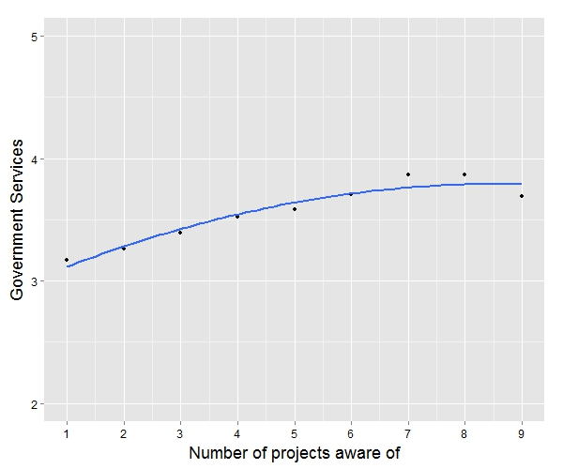

Illustration of the MISTI finding that despite a lack of information about treated villages, respondents who reported being aware of service delivery projects in their area typically assessed the quality of public services 4-6 percent higher per project on a 5-point rating scale than those who did not report being aware. This effect persisted until approximately four projects reported, with diminishing returns setting in after four projects.

Annex 2: MISTI formulation of stability and resilience measurement constructs

Stability
Resilience
Community Cohesion
Quality of Life
Local Governance
Government Capacity
Provincial Government Performance
Local Leader Satisfaction
District Government Performance
Social Capital
Local Leader Performance
DDA-CDC Performance
District Government Satisfaction

In MISTI, stability and resilience indices consisted of two levels of constituent measures which were themselves multi-item indices. A total of 27 survey items contributed to these two high-level measures, and included an additional 11 disaggregations to examine the substituent parts of stability and resilience.
Annex 3: Selected Bibliography

Evaluability Assessment for Impact Evaluation: Guidance, Checklists, and Decision Support. Greet Peersman, Irene Guijt, Tiina Pasanen, 2015.

The Evaluability of Democracy and Human Rights Projects: A Log-Frame Related Assessment. ITAD and ODI, 2000.

GoBifo project evaluation report: Assessing the impacts of community driven development in Sierra Leone. Katherine Casey, Rachel Glennerster, and Edward Miguel. October, 2013.

MISTI Stabilization Trends and Impact Evaluation. MSI and D3 Systems. November, 2015.

Planning Evaluability Assessments: A Synthesis of the Literature with Recommendations. Rick Davies, 2013.

Planning for Cost Effective Evaluation with Evaluability Assessment. Impact Assessment Primer Series #6. Elizabeth Dunn, 2008.

Randomized Impact Evaluation of Afghanistan’s National Solidarity Programme. Andrew Beath, Fotini Christia, Ruben Enikolopov. July, 2013.

Annex 4: Assessment Scope of Work: Evaluation Design Expert
Activity Summary
Under the Jordan Monitoring and Evaluation Support Project (MESP), MSI is conducting an assessment of the feasibility of conducting an impact evaluation focused on some of the interventions under USAID Cities Implementing Transparent, Innovative, and Effective Solutions (CITIES) Activity. This activity will focus on making municipal governance more effective in Jordan through development of innovative and sustainable solutions to service delivery, capacity constraints, and community cohesion in the governance structures that are closest to citizens. In addition to assessing the feasibility of conducting an impact evaluation, this assessment will help inform USAID’s implementation decisions for the CITIES Activity.
Responsibilities
Working with the MESP team, the evaluation design expert will lead the assessment of the feasibility of conducting an impact evaluation. As part of this work, the design expert will also highlight and recommend key implementation considerations, in case any, associated with conducting an impact evaluation.
Following is a detailed summary of the evaluation design expert’s responsibilities:
- Provide expert technical leadership for assessing the feasibility of conducting an impact evaluation to measure the activity’s impact on improving municipal governance.
- Review key activity documents including the work plan (draft and final), notes from the activity meetings with key stakeholders and consultations with USAID and the activity team.
- Provide key recommendations related to implementation, in case any. This may include recommendations related to selection of municipalities and/or the phasing approach of the activity.
- Identify the key assumptions and conditions required for conducting an impact evaluation, especially as they relate to the work plan.
- Identify the potential external validity of the impact evaluation, that is the extent to which the findings from the evaluation will be useful/relevant for widespread adoption.
- Lead the process of drafting a brief memo that summarizes the key findings and recommendations.
- Participate in sharing the findings in recommendations to USAID and other activity stakeholders.
- Submit all deliverables required in expected timeline.
Deliverables
Below is a list of deliverables for which the evaluation team lead will have the primary responsibility:
- Memo summarizing the key findings and recommendations.
- Written feedback and comments on draft work plan and any other activity-specific material shared.
Period of Performance December 7 to December 31
Estimated LOE The short-term assignment will start in early December 2016, and will include up to five days of LOE.

U.S. Agency for International Development
1300 Pennsylvania Avenue, NW
Washington, DC 20523

CITIES draft workplan (23 Nov 2016), pgs 9, 13, and 23-24.
USAID Evaluation Policy, 2016 update, page 9.
“Upon completion of an evaluability assessment, the evaluation team will have gained detailed knowledge of the program; program stakeholders will have agreed upon a well-developed causal model; a basic design for the impact assessment will have been developed; and the evaluation team will have collected sufficient information about local resources, logistical issues, and potential methodological challenges to proceed with the detailed design and implementation of the impact assessment.”
Note that this assessment criterion corresponds to the recent USAID practice of building, exploring, and testing learning agendas around specific development questions within and across projects and activities.
October 12, 2016 version, page 26.
See Annex 1 for an example of how MISTI measured an improvement in perceived government effectiveness, based only on the respondents' report of being aware of development projects being implemented in their community.
See Annex 2 for a schematic of how MSI hypothesized the measurement constructs of stability and resilience in MISTI through multi-item, multi-component indices.

